**Unit 22 - Task 3 Data Dictionaries, Testing and Evaluation**

**Mohammed Mahin Ibnay Mamun - 346584**

* **Introduction to data dictionaries**

**What are data dictionaries?**

The contents and fields of a database are contained within data dictionaries, which serve as the structure for a database. Data Dictionary describes data elements that are used in databases, information systems, or research projects and includes names, definitions, and attribute details for each.

**Why are data dictionaries used?**

* Help with avoiding data inconsistencies across projects
* Provide guidelines for the application of conventions across a project
* Keeping data consistent across multiple members of the research team
* Streamline the process of analyzing data
* Ensure that standard data is used

**Advantages of Data dictionaries:**

* Any organization can benefit from it since it provides documentation.
* To understand requirements and design, it is a useful tool for management and other development team members.
* By simplifying the structure, it helps the analyst meet the data requirements of the system.

**Disadvantages of Data dictionaries:**

* No functional details are provided.
* Many nontechnical users disapprove of it.

**Data Dictionary for Tameside General Hospital:**

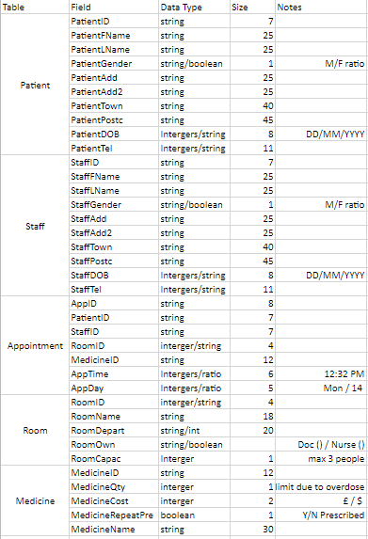

An improved booking system can be achieved at Tameside General Hospital with the help of a data dictionary. Currently, there are a lot of errors in the system. But if we run a test on it, we can find the errors and fix them

**Methods of testing a system:**

Using this method, you can test a system in a very straightforward manner, below are the steps

* Creating a test plan is the first step.
* Design and develop test scripts for system tests.
* prepare the test data.
* Test the system according to the script.
* Fixing the bugs and retesting them afterward.
* Continually test until the system is ready for deployment.
* A signature from the testing team is required.

**Volume Testing:**

Testing of the performance of the software by increasing the volume of data that is available in the database is known as volume testing, also called flood testing. It is performed to analyze the performance of the system.

**Why do volume testing?**

1) Increase the volume of data in the database to check system performance.

2) Identify the problems which may arise from enormous amounts of data.

3) Calculate when a system becomes stable.

**What does it include?**

* See if it responds in a timely manner
* Verify that the current location has data stored.
* Make sure the complete system is tested for volume.

**Advantages of volume testing**

* Scalability plans and executions enable quicker decisions
* Through it, challenges can be identified
* Having the assurance of a fully functioning system is important

**Multiplatform Testing:**

Multiplatform testing involves testing a system on several different platforms to determine whether it works correctly.

The main advantage to multiplatform testing is that you can see a difference in approach to user interface. This is clearly done if you test from two completely different devices. For example, viewing from a mobile device and a desktop monitor.

However, the only disadvantage to this sort of testing is that it can be time-consuming which can lead to missing deadlines or incompletion.

**Usability Testing:**

An indispensable component of usability testing is the usability test, which indicates directly how real users interact with the system. It is used in user-centered interaction design to evaluate products.

**Why is usability testing important**

* The purpose of the test is to determine whether the product meets users' expectations.
* Shows how successful users are at completing their tasks.
* The product is made better by removing errors and bugs.

**Advantages:**

* User expectations are met.
* Provides greater user experience.
* Detect and fix hidden errors and bugs

**Disadvantages:**

* Overly expensive
* Can cause arguments
* Difficult to run

**Planning testing for the new system:**

The first step when it comes to creating a new system is to outline the project and plan the way it will be developed, tested, and maintained. This is highly beneficial further on in the task. People link this method to SDLC. Software development life cycle.

An important phase of any development project is determining exactly what it is that you want to accomplish (planning). During this phase, you will decide and design exactly what you want to do.

**Why is planning important?**

* Establishes project goals.
* The budget and resources available are determined.

**Test plan for the new system:**

It is the Test Plan that assists us in determining how much effort will be required to validate the accuracy of the application under test.

**Testing schedule:**

Testing schedule is used to describe how the tests will be conducted, the responsibilities and the schedule of the tests. It should also describe the process for reviewing, tracking, and authorizing the test.

**Testing data:**

In the case of computer applications, test data is data that has been specifically selected for use in testing. By doing this, the software remains functioning even if the end user enters incorrect data during use or purposefully manipulates it with their actions.

**Evaluation of the system**

Firstly, I drafted / planned out what I wanted the final system to look like. Once that was done, I created some examples. By analyzing these examples against the tests, I was able to determine their effectiveness and what areas needed improvement. Using my feedback, I reviewed and retested them repeatedly until I finally minimized the errors and bugs in the system.

**How did I plan, record, and set relevant targets with timescales for your system? How did I use the feedback gathered?**

My first step was to create a timescale, which is like an action plan, which I could use to track my schedule. As a result, I was able to stay on top of things and not fall behind in this task.

This task required a great deal of planning on my part. For example, I created many flowcharts, several flow diagrams and many data flow diagrams. I also had to plan these again after the testing phase. This meant I had to recreate another design.

By keeping copies of each draft, I was able to successfully record all the data. This task required me to make a copy of the original file instead of saving over it. Therefore, I could return to the original when needed.

By establishing a timetable, I was able to manage my time effectively and completed this entire task before a deadline to a great standard. As a result, I had plenty of time to work on other projects and expand my knowledge of other software and tools.

**How did I demonstrate professionalism, etiquette, appropriate leadership, and accountability when creating this system?**

As the designer of the new system, I demonstrated professionalism by conducting appropriate research. I researched different methodologies and frameworks for creating software, as well as tools and techniques to create the system to a great level standard. Luckily, the previous research I had conducted on software development helped inform my decisions and choices on how to plan, design and create the new system.

Being considerate of the software development team while creating the system proved to be an effective leadership move. For the software development team to develop the system according to the requirements of the hospital, I created easy-to-read documentation that they could use while designing the system. To accomplish this task, I created flowcharts, data flow diagrams, and user interfaces.

My responsibility for the development of the system also consisted of considering many factors that would cause issues. I assessed potential constraints and issues with the system based on factors such as cost and time, as well as performance deadlines for certain parts of it.

**How did I evaluate outcomes to help inform high-quality, justified recommendations and decisions?**

In order to evaluate the system, I tested it and asked others to try it. This allowed me to have multiple opinions on it. I was able to understand what I needed to change after reviewing it myself and getting feedback from others. Having worked on the previous feedback, I also had several new people test it. I thought it would be more effective if I let somebody else test it rather than someone who had already tested it before.

**How did I demonstrate communication skills?**

As part of this project, most of the communication occurred during the feedback and testing phase. I also had conversations with a few people at the outset about ideas for the planning phase at the beginning.